*작성자: 이민우*<br>  
*작성일: 20210330*<br>  
*문서 목적 : 인프라 (REDMINE) 인수인계*<br>

#### 도커 파일 경로

git clone https://gitlab.com/aibigdata/helmcharts.git  
cd customRedmine/docker-redmine-custom

*구성 파일*

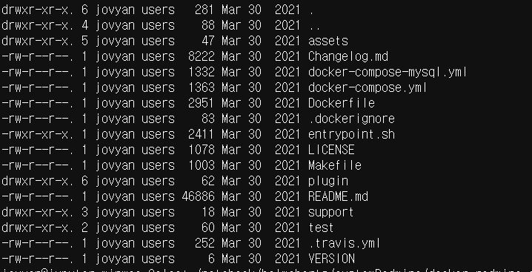

* 현 repo의 docker-redmine 디렉토리는 semeerin님이 만드신 redmine 이미지에 5개의 plugin과 theme를 추가해 둔 Dockerfile
* *docker-redmine-custom/plugin 의 plugins 디렉토리에 가서 압축파일 해제*

customRedmine/docker-redmine-custom/Dockerfile

FROM ubuntu:xenial-20190222 AS add-apt-repositories  
  
RUN apt-get update \  
 && DEBIAN_FRONTEND=noninteractive apt-get install -y wget \  
 && apt-key adv --keyserver keyserver.ubuntu.com --recv E1DD270288B4E6030699E45FA1715D88E1DF1F24 \  
 && echo "deb http://ppa.launchpad.net/git-core/ppa/ubuntu xenial main" >> /etc/apt/sources.list \  
 && apt-key adv --keyserver keyserver.ubuntu.com --recv 80F70E11F0F0D5F10CB20E62F5DA5F09C3173AA6 \  
 && echo "deb http://ppa.launchpad.net/brightbox/ruby-ng/ubuntu xenial main" >> /etc/apt/sources.list \  
 && apt-key adv --keyserver keyserver.ubuntu.com --recv 8B3981E7A6852F782CC4951600A6F0A3C300EE8C \  
 && echo "deb http://ppa.launchpad.net/nginx/stable/ubuntu xenial main" >> /etc/apt/sources.list \  
 && wget --quiet -O - https://www.postgresql.org/media/keys/ACCC4CF8.asc | apt-key add - \  
 && echo 'deb http://apt.postgresql.org/pub/repos/apt/ xenial-pgdg main' > /etc/apt/sources.list.d/pgdg.list  
  
FROM ubuntu:xenial-20190222  
  
LABEL maintainer="sameer@damagehead.com"  
  
ENV RUBY_VERSION=2.4 \  
 REDMINE_VERSION=4.0.6 \  
 REDMINE_USER="redmine" \  
 REDMINE_HOME="/home/redmine" \  
 REDMINE_LOG_DIR="/var/log/redmine" \  
 REDMINE_ASSETS_DIR="/etc/docker-redmine" \  
 RAILS_ENV=production  
  
ENV REDMINE_INSTALL_DIR="${REDMINE_HOME}/redmine" \  
 REDMINE_DATA_DIR="${REDMINE_HOME}/data" \  
 REDMINE_BUILD_ASSETS_DIR="${REDMINE_ASSETS_DIR}/build" \  
 REDMINE_RUNTIME_ASSETS_DIR="${REDMINE_ASSETS_DIR}/runtime"  
  
COPY --from=add-apt-repositories /etc/apt/trusted.gpg /etc/apt/trusted.gpg  
  
COPY --from=add-apt-repositories /etc/apt/sources.list /etc/apt/sources.list  
COPY --from=add-apt-repositories /etc/apt/sources.list.d/pgdg.list /etc/apt/sources.list.d/  
  
RUN apt-get update \  
 && DEBIAN_FRONTEND=noninteractive apt-get install --no-install-recommends -y \  
 supervisor logrotate nginx mysql-client postgresql-client ca-certificates sudo tzdata \  
 imagemagick subversion git cvs bzr mercurial darcs rsync ruby${RUBY_VERSION} locales openssh-client \  
 gcc g++ make patch pkg-config gettext-base ruby${RUBY_VERSION}-dev libc6-dev zlib1g-dev libxml2-dev \  
 libmysqlclient20 libpq5 libyaml-0-2 libcurl3 libssl1.0.0 uuid-dev xz-utils \  
 libxslt1.1 libffi6 zlib1g gsfonts vim-tiny \  
 && update-locale LANG=C.UTF-8 LC_MESSAGES=POSIX \  
 && gem install --no-document bundler \  
 && rm -rf /var/lib/apt/lists/*  
  
COPY assets/build/ ${REDMINE_BUILD_ASSETS_DIR}/  
  
RUN bash ${REDMINE_BUILD_ASSETS_DIR}/install.sh  
  
COPY assets/runtime/ ${REDMINE_RUNTIME_ASSETS_DIR}/  
  
COPY assets/tools/ /usr/bin/  
  
############### 기존 원본 도커파일에서 추가 된 부분   
RUN mkdir ${REDMINE_DATA_DIR}  
  
RUN mkdir ${REDMINE_HOME}/temp  
  
### 플러그인 이동   
COPY plugin/. ${REDMINE_HOME}/temp/   
##############  
COPY entrypoint.sh /sbin/entrypoint.sh  
  
RUN chmod 755 /sbin/entrypoint.sh \  
 && sed -i '/session required pam_loginuid.so/c\#session required pam_loginuid.so' /etc/pam.d/cron  
  
EXPOSE 80/tcp 443/tcp  
  
WORKDIR ${REDMINE_INSTALL_DIR}  
  
ENTRYPOINT ["/sbin/entrypoint.sh"]  
  
CMD ["app:start"]

customRedmine/docker-redmine-custom/entrypoint.sh

#!/bin/bash  
set -e  
source ${REDMINE_RUNTIME_ASSETS_DIR}/functions  
  
[[ $DEBUG == true ]] && set -x  
  
case ${1} in  
 app:init|app:start|app:rake|app:backup:create|app:backup:restore)  
  
 initialize_system  
 configure_redmine  
 configure_nginx  
  
 case ${1} in ########### 플러그인 설치 부분 redmine을 구성한 unicorn 의 설정 때문에 하나씩 설치   
 app:start)  
 version_check  
 migrate_database  
 cp ${REDMINE_HOME}/temp/plugins/redmine_agile ${REDMINE_DATA_DIR}/plugins -r  
 install_plugins  
 sleep 5  
 cp ${REDMINE_HOME}/temp/plugins/redmine_ckeditor ${REDMINE_DATA_DIR}/plugins -r  
 install_plugins  
 sleep 5  
 cp ${REDMINE_HOME}/temp/plugins/redmine_dmsf ${REDMINE_DATA_DIR}/plugins -r  
 install_plugins  
 sleep 5  
 cp ${REDMINE_HOME}/temp/plugins/redmine_messenger ${REDMINE_DATA_DIR}/plugins -r  
 install_plugins  
 sleep 5  
 cp ${REDMINE_HOME}/temp/plugins/redmine_gitlab_hook ${REDMINE_DATA_DIR}/plugins -r  
 install_plugins  
 sleep 5  
 cp ${REDMINE_HOME}/temp/plugins/redmine_gitlab_hook ${REDMINE_DATA_DIR}/plugins -r   
 sleep 5  
   
 cp ${REDMINE_HOME}/temp/themes/circle ${REDMINE_DATA_DIR}/themes -r  
 install_themes  
  
 if [[ -f ${REDMINE_DATA_DIR}/entrypoint.custom.sh ]]; then  
 echo "Executing entrypoint.custom.sh..."  
 . ${REDMINE_DATA_DIR}/entrypoint.custom.sh  
 fi  
  
 rm -rf /var/run/supervisor.sock  
 exec /usr/bin/supervisord -nc /etc/supervisor/supervisord.conf  
 ;;  
 app:init)  
 version_check  
 migrate_database  
 install_plugins  
 install_themes  
 ;;  
 app:rake)  
 shift 1  
 execute_raketask $@  
 ;;  
 app:backup:create)  
 shift 1  
 backup_create $@  
 ;;  
 app:backup:restore)  
 shift 1  
 backup_restore $@  
 ;;  
 esac  
 ;;  
 app:help)  
 echo "Available options:"  
 echo " app:start - Starts the Redmine server (default)"  
 echo " app:init - Initialize the Redmine server (e.g. create databases, install plugins/themes), but don't start it."  
 echo " app:rake <task> - Execute a rake task."  
 echo " app:backup:create - Create a backup."  
 echo " app:backup:restore - Restore an existing backup."  
 echo " app:help - Displays the help"  
 echo " [command] - Execute the specified command, eg. bash."  
 ;;  
 *)  
 exec "$@"  
 ;;  
esac

***플러그인을 추가 설치하고 싶다면***

1. 현재 레드마인과 호환성을 고려 (4.0.6) <br>
2. plugin 디렉토리 내에 압축 해제해서 디렉토리 형태로 첨부 <br>
3. entrypoint 에 plugin 설치 커맨드 기입

**현재 설치된 플러그인**

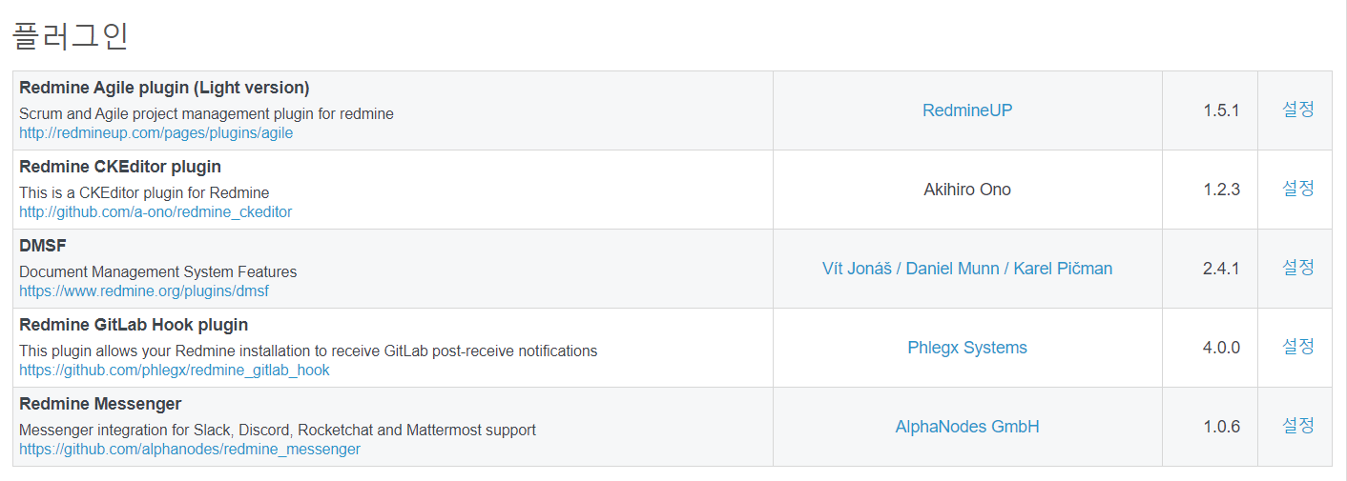

**플러그인 출처**

redmine agile : <https://www.redmine.org/plugins/redmine_agile>  
<br>  
redmine ckeditor : <https://www.redmine.org/plugins/redmine-ckeditor>  
<br>  
redmine dmsf : <https://www.redmine.org/plugins/redmine_dmsf>  
<br>  
redmine gitlab hook : <https://github.com/phlegx/redmine_gitlab_hook>  
<br>  
redmine messenger : <https://www.redmine.org/plugins/redmine_messenger>

원본 출처 : <https://hub.docker.com/r/sameersbn/redmine>